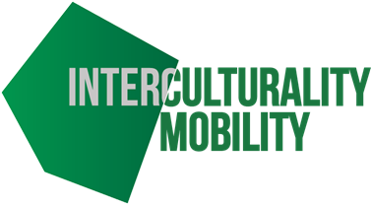
Self-assessment and refection form
Name | Date
Module | Unit
Things I already knew something about
New ideas I learnt about today
Things I need to learn more about
Date by which I will complete the online activities

