Case Study – Ollie Clarke

Ollie Clarke shares his experience of a Leonardo placement that led to him developing employability and entrepreneurship skills.
It was tough, but it was a fantastic opportunity and it set me on the path for where I am now.

Read the full case study at:
https://www.erasmusplus.org.uk/stories/30-years-story-cornwall-council

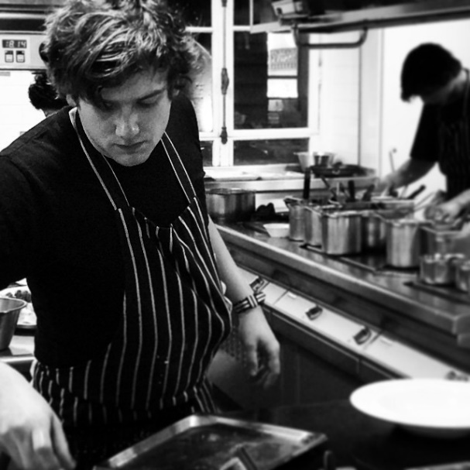
Ollie's story
Ollie took part in a two-week Leonardo Mobility placement in 2008 organised by Cornwall Council. He did his placement at The Hotel Warwick in Paris. The intercultural mobility took place during the years that Ollie was training to be a chef at The Seafood Restaurant, a famous restaurant in Padstow, Cornwall, England.

"Coming from Padstow to Paris was certainly a big eye-opener for us; slowly but surely we began to learn more and gain more responsibility over the two weeks.”
After finishing his apprenticeship in Padstow, Ollie moved to Paris and eventually became a chef in some top Parisian restaurants.

Ollie says that before the intercultural experience, the idea of moving to Paris would have been scary. “But actually being here and living it for two weeks, made us (Ollie and his life partner and business partner, Julie Duckett) realise that it’s not too difficult.”

“It was hard, but it was very enjoyable, and it opened the gates for us to decide to move to Paris which was a huge step in our lives and our careers so I’m very grateful to it. It was tough and that shouldn’t be underestimated, coming into a Parisian kitchen is a challenge, but one that I couldn’t recommend highly enough.”

Questions
- Where did Ollie and Julie do their mobility placement?

- How can you tell that their experience reinforced their resilience and perseverance?

