Case Study - Fred Brant

Read the full case study at: https://www.erasmusplus.org.uk/stories/leicester-college

Leicester is ranked within the 10% most deprived local authorities in England where one in three people live in areas of high education deprivation (Leicester City Council, 2016). But Leicester College is making it their goal to provide experiential learning opportunities for participants through an international work placement, targeting young people who have not previously had the chance to travel.

Through the ‘Electrical Maintenance Experience’ and ‘Leicester College Construction’ Key Action 1 Mobility for Vocational education and training (VET) projects, the college has been recruiting learners to spend four to six weeks in Seville, Spain. During this time, they are placed in local companies to improve their work based knowledge and skills and increase their work readiness.

Fred Brant was studying towards his Level 2 in Electrical Installation. He went on the Seville placement and has secured an apprenticeship as a result of his Erasmus+ experience.

Fred feels he became more independent from being away and secured his apprenticeship with Blaby Electrical as a result. While at the interview for the apprenticeship, Fred commented that "they were very interested in the placement in Seville. It was a great conversation starter at the interview". Fred would recommend this placement to anyone and was really happy the college pushed him to go abroad: "The College really helps push you forward, Neil always finds the best options for you."

While in Spain, Fred worked on a variety of techniques and skills as well as doing English-Spanish lessons on a Wednesday with local people. For Fred, the language barrier wasn't a barrier at all; it ended up being one of his favourite elements of the placement. Fred's top tip would still be: learn more Spanish! Placement coordinator Neil encouraged the learners to download a language learning app, before they went to Seville abroad and gave them Spanish language vocabulary tasks to help them learn specialist vocabulary they would need. But as Fred noted, to learn languages "it’s always better talking to people than using an app".

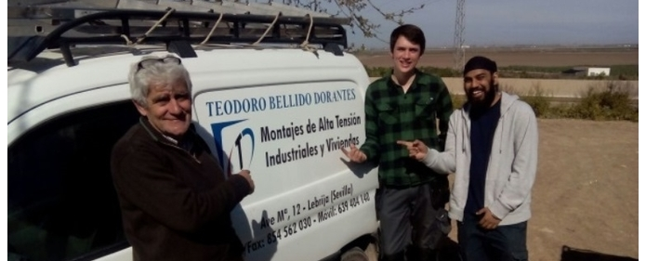
Other learners also gained something from taking part. Participant Khaleem Mohamed said: “A key learning experience was being on site in a different country and learning about how they handle electrical work and how the work is carried out. This has given me confidence that electrical work is what I want to do in future. It was a great way to meet new people, interact, learn more about where I was staying and increase my Spanish. This trip has helped me professionally and socially as I have gained confidence and expanded my skills such as- communication skills, punctuality, confidence in face to face communication and listening skills.”

Another learner who had been studying electrical maintenance from Level 1: had hardly spoken at all during his time at Leicester College. However, since returning from Seville, he is chatty, confident and bubbly; he is like a different person.

Yet another learner was nearly removed from the course, because he had the wrong attitude and his attendance was poor. However, after going to Seville, he was motivated to improve his performance. There has been a complete turnaround; he is now a model learner, gaining credits and distinctions for his work.

Questions
- What type of learners went on the VET mobility to Seville?

- What skills/ benefits did Fred, Khaleem and the other two learners gain from the opportunity to go to Seville?

- How might these benefits and developments help all four learners in the future?

