Case Study – Go Further, Reach Higher

Read the full case study at:
https://www.erasmusplus.org.uk/stories/everything-is-possible

Over 90 young people from the UK, took part in a project which included the experience of an international training opportunity which would last for two weeks.

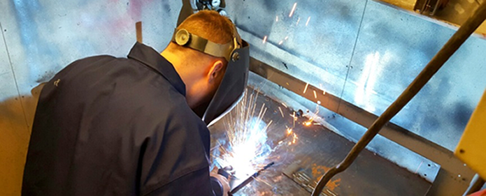

Many of the participants were young people who had experienced social exclusion, who had additional support needs or who were early school leavers. They came from five diverse vocational institutions in the UK, but were coordinated by a ‘not-for-profit’ organisation called Everything is Possible. This organisation, which is based in Yorkshire, has been providing inclusion opportunities to UK participants for over 16 years. The organisation Everything is Possible led a project called Go Further, Reach Higher.

As a result of the Key Action 1 VET mobility project, 84% of the participants who undertook the two-week work experience placement outside the UK, are still studying in their chosen subject areas and progressing in their professional lives.

The young trainees were all selected from UK VET providers from either the animal management or carpentry provisions, and ranged between 17 and 25 years old.
Many of them were on the verges of their vocational courses, struggling with integration or experiencing significant obstacles outside of college. Much of the training programme related to soft skills and aimed to develop the young people’s job-readiness, appropriate social behaviour, work ethic and cultural awareness.

The overall idea was inclusion through mobility. “Erasmus+ has helped us to further the lives of young people that are on the verges of exclusion.” said Clair Brown, from the organisation Everything is Possible.

Participants took part in a two-week work experience placement which was relevant to their vocational field. This included carpentry organisations in Portugal and Sweden, a cat sanctuary in Malta or a donkey sanctuary in Aruba. Participants took part in practical activities in line with their chosen industry and studies back home.
Tracey Law, a trainee veterinary nurse from Huddersfield, travelled to Aruba to develop her professional skills and gain work experience to help her reach her goal of becoming a vet. During the placement at a donkey sanctuary she carried out various health treatments for the animals including tetanus vaccinations. Since returning, she was offered a full-time job in a vet practice.

One of the biggest learning outcomes from the project was the improved communication of participants. On their return to the UK, the young people were asked to present their experiences in a number of innovative ways. This included creating a comic strip of their placement, Powerpoint presentation, videos and sharing verbally with other students in their tutor group back within their own college setting.

Questions
- What type of learners were identified to take part in intercultural mobilities?

- What skills/ benefits did the participants acquire during their placements?

- How might these skills be useful in the future?

