Case Study – Bolton at Home

https://www.erasmusplus.org.uk/stories/bolton-at-home

Bolton at Home is a charitable, community benefit society, that provides social housing. Bolton at Home owns and manages more than 18,000 homes in the Bolton Metropolitan Borough Council, near Manchester, England.

Bolton at Home coordinated an Erasmus+ Key Action 1 Vocational education and training (VET) project called 'Building Better Futures'.

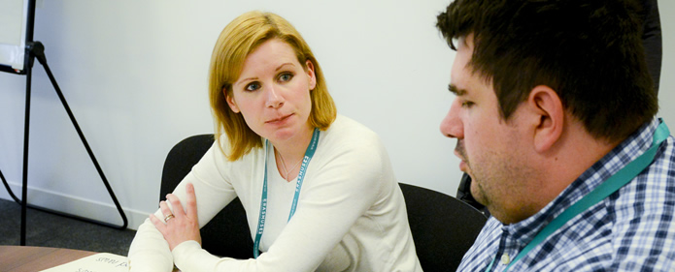

It organised volunteers from the city of Bolton to travel to parts of Eastern Europe to take part in a two-week project that improved the lives of people living in deprived areas.

A group of 12 went to Romania, where they worked in partnership with FAST Charity Romania to improve the homes of the Roma communities within villages across Sacele. As well as building work, which included connecting houses to a water supply, the volunteers spent time at the ‘integration centre’ and supported the education of children and their families and their integration into the wider community.

Barrie and Tara, two officers from Bolton at Home, explained that the project was "targeting people that are on our estates, not in employment or education and we’re trying to engage with them, get them involved and show them that there is a future."

They also report that when participants return “there’s a massive change in their maturity, their ability to look at things differently, see that they have a sense of achievement and they can do things and progress and get employment or remain in education and develop themselves.”

Watch Barrie and Tara talk about their work on Youtube:
https://www.youtube.com/watch?time_continue=2&v=lWPq3hm6Y_o

Questions
- What type of learners went on the VET mobility to Romania?

- What did the organisers Barrie and Tara identify as the biggest change in the participants following the mobility?

- How might this learning be useful in the future?

